# MGT 388 Finance and Law for Engineers

# Finance Lecture 3 Notes

# Introduction

For all **incorporated businesses** an **Annual Report** must be produced for the shareholders of the company. Although the Annual reports are prepared for the owners (shareholders) of the company, they are publicly available and can be used by any stakeholders in the company to make economic decisions.

***Incorporated business*** -a company can be registered as:

* A private limited company (Ltd) 私人有限公司
* A public limited company (plc) 公共有限公司

A plc can offer its shares for sale to the public, but a Ltd company cannot.

plc 可以向公众出售其股票，但 Ltd 公司不能。

A plc may issue shares for sale on the Stock Exchange. These shares can then be re-traded on the stock exchange so the ownership of a plc may be constantly changing. Individuals may hold shares, but it is pension funds, insurance companies and other financial institutions which hold large blocks of shares.

有限责任公司可于联交所发行股份出售。然后，这些股票可以在证券交易所重新交易，因此plc的所有权可能会不断变化。个人可以持有股票，但持有大量股票的是养老基金、保险公司和其他金融机构。

**Annual Report** = Accounts = Financial statements

This refers to the annual financial information that is published by a company under regulations and which is subject to an audit. The annual report contains four main financial statements together with notes explaining those statements:

* The income statement.
* The statement of financial position.
* The statement of changes in equity.
* The statement of cash flow.

The Annual Reports of major companies now also contain a lot of narrative information only some of which is regulated.

The information in the annual reports can be used as a marketing tool by the company to attract customers, suppliers of finance, good press as well as investors. They will highlight a company’s objectives which may be profit focused, but as the importance of corporate social responsibility has become more widely recognised there will be other objectives.

大公司的年报现在也包含很多叙述性信息，只有部分信息受到监管。 年报中的信息可以作为公司的营销工具，以吸引客户、融资供应商、媒体和投资者。它们将突出公司的目标，这些目标可能以利润为中心，但随着企业社会责任的重要性得到更广泛的认可，也会有其他目标。

# Regulation

1. Statutory regulation - Companies Acts and European Union Directives

The 2006 Companies Act contains detailed regulation to protect shareholders and creditors.

* Requirement to prepare annual accounts that must give a true and fair view and be prepared in accordance with either international accounting standards or national accounting standards.
* Details when an audit is required and
* Outlines the company’s duty to file and circulate the annual report

1. Accounting standards

UK Accounting Standards Board and the International Accounting Standards Board.

1. Stock exchange regulation

More frequent and more detailed reporting.

# Audit审计

An audit is an independent examination of the financial statements to establish that they show a true and fair view of the financial performance (profit) and position (value/worth) of the company.

An audit will not guarantee that the financial statements are correct, but just true and fair. It was also noted earlier that the audit does not cover all the information in the annual report.

There have been many accounting scandals most recently Tesco’s.

审计是对财务报表的独立检查，以确定它们对公司的财务业绩（利润）和状况（价值/价值）的真实和公允的看法。 审计不能保证财务报表是正确的，而只是真实和公允。前面还指出，审计工作并未涵盖年度报告中的所有信息。 有许多会计丑闻，最近的是乐购。

# Concepts that Underlie the Preparation of Financial Statements

## Separate Entity

In company law, the company is a person. It has a separate legal identity from its owners, the shareholders and the management and directors of the company.

It is the company that will sue and can be sued.

在公司法中，公司是一个人。它具有独立于其所有者、股东以及公司管理层和董事的法律身份。 是公司会起诉，也可以被起诉。

## Double Entry 双入口

Every transaction that a company enters affects two accounts.

## Accruals/matching

Expenses are matched to the revenues that they help generate.

Expenses, costs, income, and revenue are accounted for when they are earned or incurred, not when cash flows in or out of the company.

应计项目/匹配 费用与它们帮助产生的收入相匹配。 费用、成本、收入和收入在赚取或发生时入账，而不是在现金流入或流出公司时入账。

## Importance of regulation and concepts

Stakeholders (shareholders, employees, providers of goods and finance) can understand a set of annual reports, compare with other companies anywhere in the world and establish how a company is performing over time.

This will allow investors to make rational decisions ensure the capital markets operate efficiently and increase the wealth and hopefully well-being of a nation.

利益相关者（股东、员工、商品和融资提供者）可以了解一套年度报告，与世界上任何地方的其他公司进行比较，并确定公司随时间推移的表现。 这将使投资者能够做出理性的决策，确保资本市场有效运作，并增加一个国家的财富和福祉。

# Profit Vs Cash

Cash position of Daley

Month 1 Month 2 Month 3 £ £ £

Cash inflow (1@8,000) 8,000 (8@8,000) 64,000 (9@8,000) 72,000

Cash outflow (6@5,000) (30,000) (12@5,000) (60,000) (0@5,000) (0)

Cash position (22,000) 4,000 72,000

The cash position is much more volatile than profits. If you just looked at the cash position of Daley in the first two months, you would not invest in the business, but if you looked at the cash position for only the third month you may invest too heavily.

Look at total cash (22,000) +4,000+72,000 = 54,000

Look at total profits 3,000 +24,000+27,000 = 54,000

The total cash generated equals the total profits generated. The accruals concept helps to show a true and fair view of how well the company is performing over a period.

But a lack of cash or an understanding of inflows and outflows of cash may mean a business cannot meet debts as they fall due and ultimately go bankrupt.

A statement of cash flow is included within the financial statements.

# Sealion plc Statement of cash flows for the year ended 31 December 2015

**£’000 £’000 Cash flows from operating activities** Profit before taxation (after interest) X Adjustments for: Depreciation X Loss/(profit) on sale of assets X/(X) Interest payable X Interest receivable (X)

Decrease/(increase) in inventories X/(X) Decrease/(increase) in trade receivables X/(X) Increase/(decrease) in trade payables X/(X) X

**Cash generated from operations X** Interest paid (X) Taxation paid (X) **Net cash from operating activities X**

**Cash flows from investing activities**  Payments to acquire non-current assets (X) Receipts from the sale of non-current assets X Dividends received X Interest received X **Net cash used in investing activities (X)**

**Cash flows from financing activities** Proceeds from the issue of shares X Proceeds from the issue of loans X Repayment of non- current loans (X) Dividends paid (X) **Net cash used in financing activities X** **Net increase (decrease) in cash X/(X) Cash at 1 June 2014 X Cash at 31 May 2015 X**

**Proforma Financial Statements based on International Accounting Standard 1 and International Accounting Standard 7**

# Financial Accounting

The field of accounting deals with the preparation of financial statements that are to be used by users external to an organisation.

The objective of financial statements is “*to provide information about the financial position, performance and changes in financial position of an entity that is useful to a wide range of users in making economic decision*” (International Accounting Standard Board - IASB Framework).

Financial position – wealth/worth (assets/liabilities/equity)

Performance – profit/loss

(e.g., for a bank account the financial position would be the funds held in the account at a point in time; the financial performance of the bank account is the interest/profit that it has earned).

Economic decisions – to invest in the company, to work for the company, to supply the company with goods, to loan funds to the company.

As the financial statements are prepared by an organisation for use by external decision makers the information must be regulated.

# Management Accounting

Management accounting encompasses “*techniques and processes that are intended to provide financial and non-financial information to people within an organisation to make better decisions and thereby achieve organisational control and enhance organisational effectiveness.”* Wilson and Chua (1993, p.16).

***Planning***

Management accountants help toformulate plans for different activities and co-ordinate these plans into budgets for the business.

***Controlling***

Management accountants produce performance reports that compare actual outcomes with planned outcomes.

***Organising***

Management accountants develop accounting reporting systems that are closely related to organisational structure to ensure organisational goals are followed by departments.

***Communicating***

Management accounting can aid the communication function by installing and maintaining an effective communication and reporting system (e.g., the budget and performance reporting process).

***Motivating***

The budgets and performance reports produced by accountants have an important influence on the motivation of managers and employees.

***Decision-making***

Providing guidance for decision making and problem-solving.

# A comparison between Financial Accounting and Management Accounting

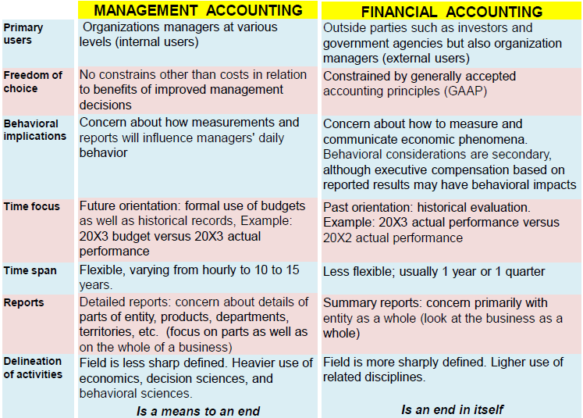

# Financial Management

Financial Management is concerned with the ways in which funds for a business are raised and used.

Finance is “*the acquisition and subsequent management of funds to support the achievement of business objectives*” (CIMA 1996).

If funds are being raised for a new venture, is a loan, overdraft, partnership, or share issue the most appropriate form of finance?

Where several projects or business opportunities are competing for finance, which one should be undertaken?

Financial management seeks to optimise the risk and return combinations from projects to enhance the value of the organisation.